A000-US-NE-Pine Ridge-Oglala Sioux-Axe-early 19th c

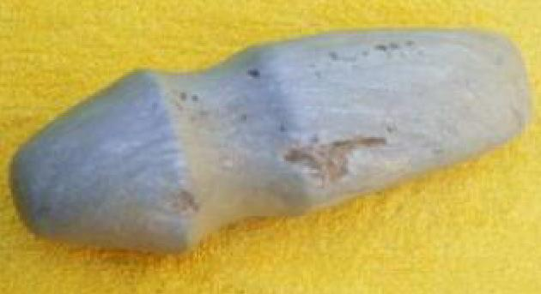

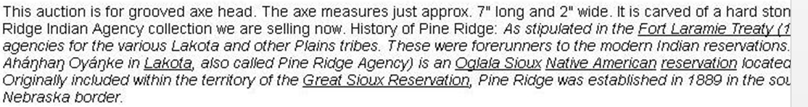

Case No. 12